Edit /etc/hosts
#nano /etc/hosts

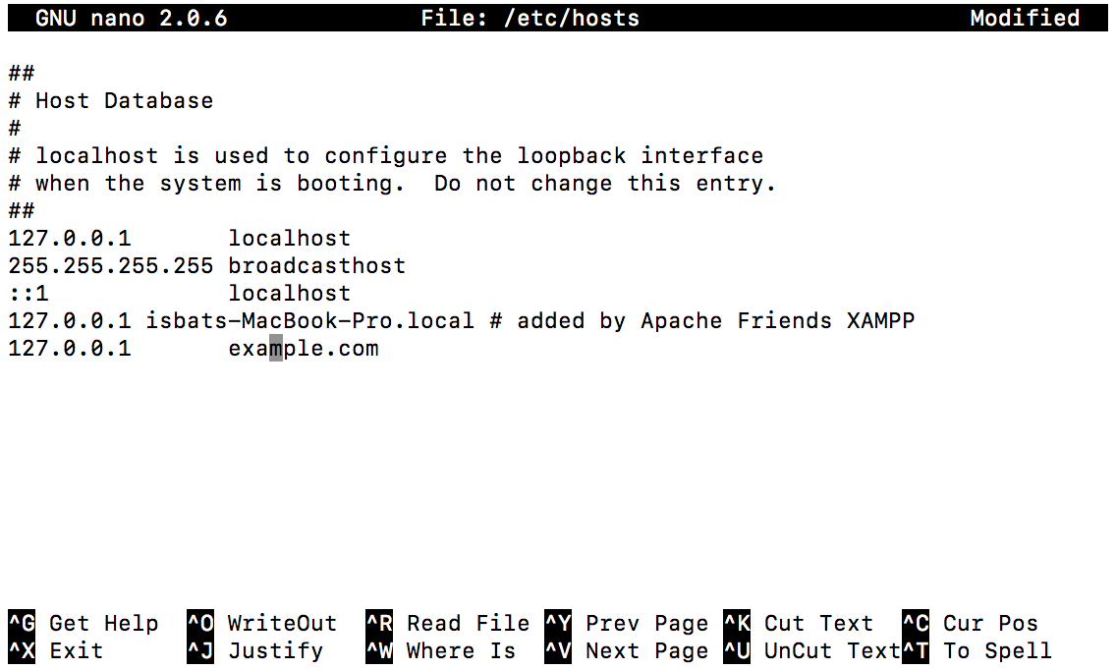

Pastikan bisa ping example.com

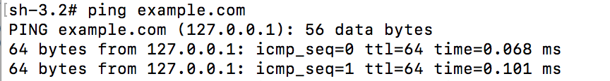

Install openssl dan apache2

#apt-get install openssl
#sudo apt-get install apache2

ENABLE SSL jalankan perintah sbb :

#a2enmod ssl
#a2ensite default-ssl
#service apache2 reload
#mkdir /etc/apache2/ssl
#openssl req -x509 -nodes -days 365 -newkey rsa:2048 -keyout /etc/apache2/ssl/apache.key -out /etc/apache2/ssl/apache.crt

akan ada masukan yang harus diisikan sbg contoh sbb :
--------------
Interactive
You are about to be asked to enter information that will be incorporated
into your certificate request.
What you are about to enter is what is called a Distinguished Name or a DN.
There are quite a few fields but you can leave some blank
For some fields there will be a default value,
If you enter '.', the field will be left blank.
——-
Country Name (2 letter code) [AU]:US
State or Province Name (full name) [Some-State]:New York
Locality Name (eg, city) []:NYC
Organization Name (eg, company) [Internet Widgits Pty Ltd]:DigitalOcean
Organizational Unit Name (eg, section) []:SSL Certificate Test
Common Name (e.g. server FQDN or YOUR name) []:example.com
Email Address []:test@example.com
----------------

Lanjutkan jalankan perintah sbb :
#chmod 600 /etc/apache2/ssl/*

Lakukan editing default-ssl dan sesuaikan dengan web anda :
nano /etc/apache2/sites-enabled/default-ssl.conf

konten
-----
<IfModule mod_ssl.c>
<VirtualHost _default_:443>
ServerAdmin webmaster@localhost
ServerName example.com:443
DocumentRoot /var/www/html

. . .
SSLEngine on

. . .

SSLCertificateFile /etc/apache2/ssl/apache.crt
SSLCertificateKeyFile /etc/apache2/ssl/apache.key
--------

service apache2 reload

untuk cek --> openssl s_client -connect your_server_ip:443

Jika ada masalah misal salah konfigurasi bisa cek dengan perintah sbb :
openssl s_client -connect your_server_ip:443
systemctl status apache2.service

